The Role of Network Architecture in the Onset of Spontaneous Activity
Diletta POZZI^{a,b*}, Nicolò MENEGHETTI^{c}, Anjan ROY^{d}, Beatrice PASTOREª, Alberto MAZZONI^{c}, Matteo MARSILI^{d} and Vincent TORRE^{a,e,f}
https://doi.org/10.37175/stemedicine.v1i1.1

Supplementary Figures
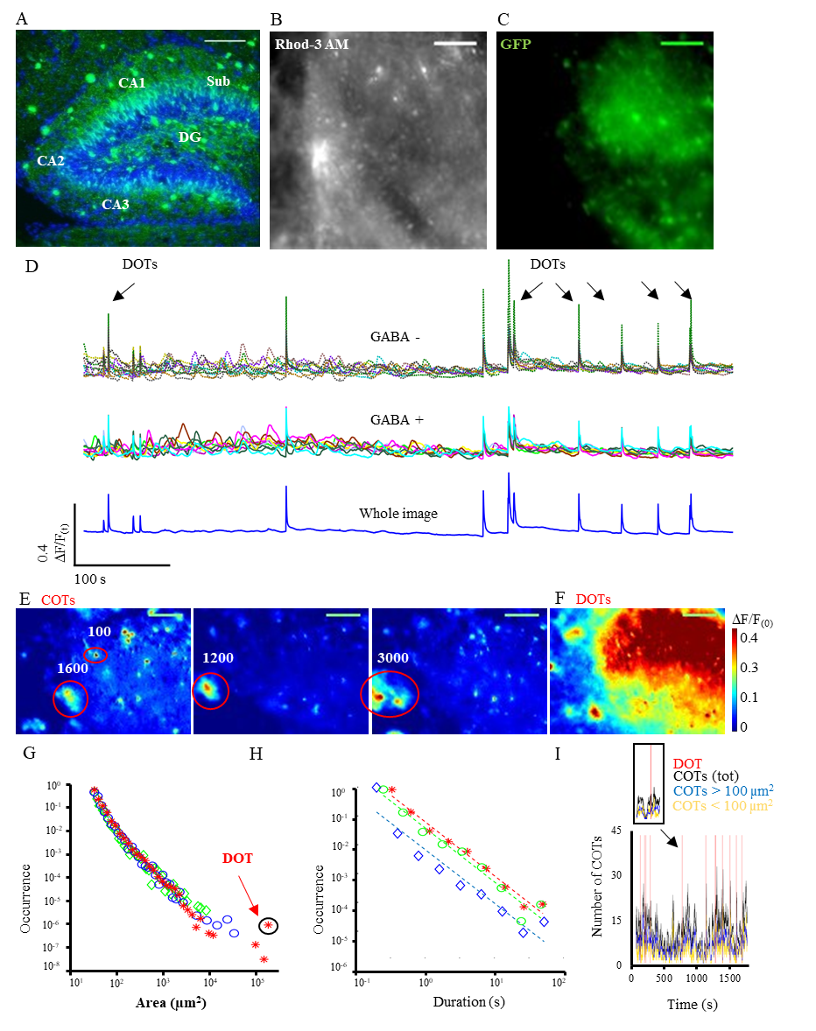
Supplementary Figure 1: Spontaneous events in the hippocampus. (A) Fluorescent image of the hippocampus from a GAD67-GFP mouse (P5) with DAPI nuclear staining; GABA+ neurons are labeled in green. The anatomical regions corresponding to the cornu ammonis fields (CA1-3), subiculum (Sub) and dentate gyrus (DG) are shown. (B) Slice loaded with the fluorescent indicator Rhod -3 AM during calcium imaging and corresponding GABA+ neurons (C) in the same field of view. (D) F/F₍₀₎ traces extrapolated from the whole image (blue trace at the bottom), from GABA+ (colored traces in the middle) and GABA- neurons (colored traces on top). (E) Examples of Confined Optical Transients (COTs) from a pseudo-color F/F₍₀₎ movie, showing isolated regions of variable sizes (see red circles; the rounded numbers are expressed in µm²). (F) example of a Diffuse Optical Transient (DOT), where the increase in F/F_{network} involves more than 50% of the imaged slice. Color bar on the right. Scale bars: 80 µm in both fluorescence and pseudo-color images. (G, H) Probability distribution of area and duration of COTs in the hippocampus. Circles, rhombus and asterisks represent data from three representative experiments: the corresponding dotted lines in (H) show the linear fitting for each distribution. DOTs are represented as outliers outside the area’s distributions (see black circle). (I) Density of COTs over time for different area sizes (COTs<100 µm² and COTs>µm², yellow and blue lines respectively) and with reference to DOTs occurrence (red vertical lines). The inset shows the decrease in COTs density corresponding to DOTs’ occurrence.

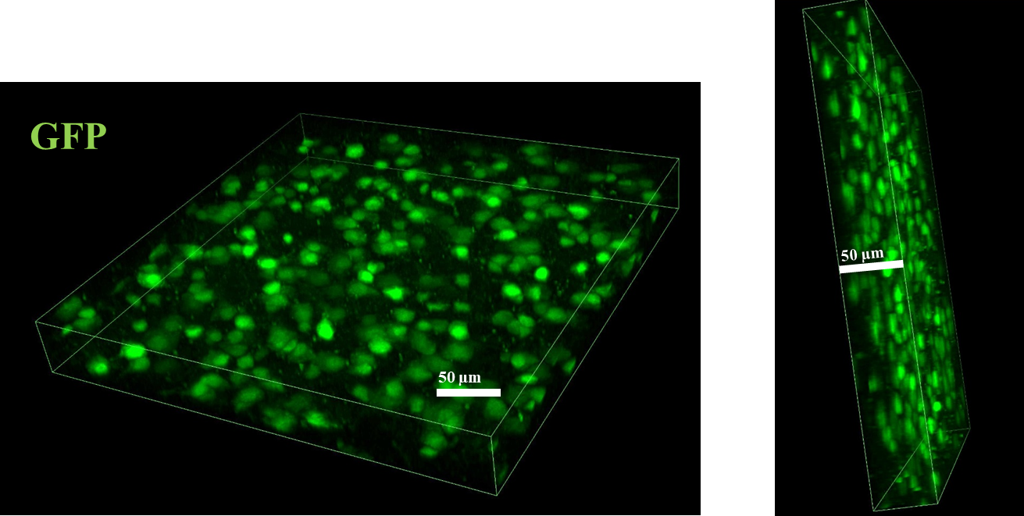
Supplementary Figure 2: Confocal 3D reconstruction of GABA+ neurons in a representative organotypic slice from GAD67-GFP mouse after 7 days in culture. The cortical region in this example was imaged with a 40x objective, in z-stack acquisition mode (26 steps of 1.9 µm each). The starting and ending point of the acquisition coincided with the most superficial and the deepest layer of cells visible by nuclear Hoechst (Sigma-Aldrich) staining (blue channel not shown in this figure).

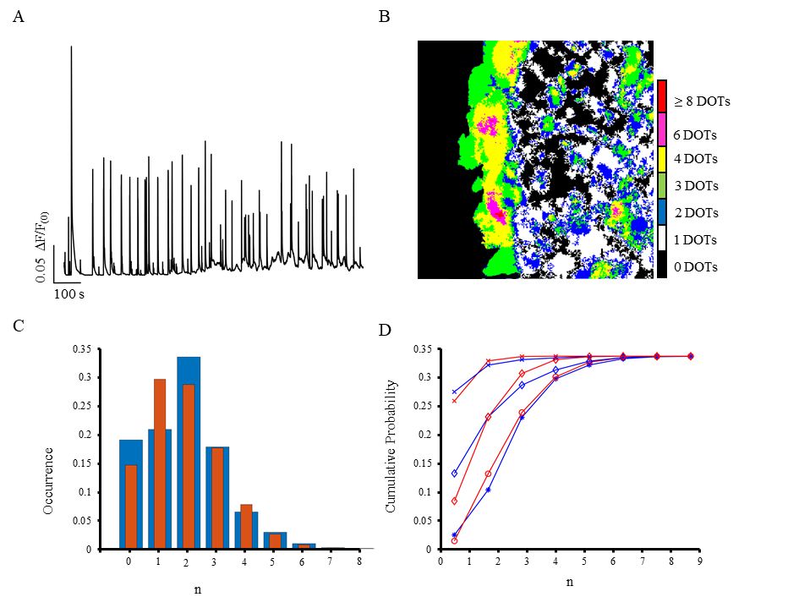
Supplementary Figure 3: Seeds of DOTs in hippocampal slices. (A) Averaged optical trace of a representative 40 min recording. (B) Sum of all binary images corresponding to seeds; different colors indicate regions activated before multiple DOTs (see color bar on the right: red regions are activated before the onset of 8 or more DOTs). (C) Probability of activation of a pixel from experimental data compared to a binomial distribution in one experiment (blue and red bars, respectively). The x – axis represents the number of trials (frames) considered. (D) Cumulative probability of pixel activation from experimental data (blue lines) compared to the corresponding binomial distributions (red lines) in three representative experiments. n = 5 slices. The two distributions were not significantly different.

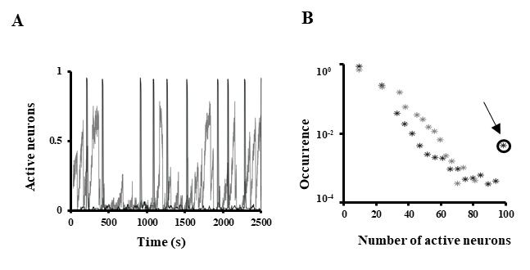
Supplementary Figure 4: Dynamics of dissociated hippocampal cell cultures, HD and MD. (A) Activation of neurons over time in MD (gray) and HD (black) cultures, normalized to the total number of neurons (100 and 56 for HD and MD cultures, in this representative experiment). (B) Probability distribution of the number of neurons simultaneously active in MD (gray marks) and HD (black marks) cultures, with corresponding DOT-like event (see circle).

